**Final Project Draft**:

Title: Using R to predict behaviors, demands and dynamics through times and distances in two cases: Predict behavior of police agent (Predator) and suspect (his prey) in a zone; Predict Blood Group_A Demand (BGAD) “Biochemical Oxygen Demand (BOD)” and Group_A (GA) “oxygen (O2)” dynamics in village “River zone”

**Introduction**

One of the of advantage of coding is to be able to extract the exact information, predict behaviors, predict demands based on people’s needs, find the dynamic of a system based on diverse factors as quickly as possible in order to propose a range of solutions to leaders who might decide what to do in any given situation.

In this project, we studied the behavior of police agents through time in an area whose mission is to capture a suspect. Note that every suspect has also a behavior which change through time and we will examine that too. In addition to that, we will examine the availability of a blood Group A through time in a village and the demand of that blood group A in the same village through time as well.

**Data**

I created my own data but those data are incorporated in the code I will developed

**Method**

I used the differential equation functions in R to get all results I was looking for in this project. For the first case, the ODE function was used in R. In the code, a model equation is shown. The flux due to diffusion, the rate of change, the model parameters, the condition are implemented. For the second case, the model equation, the model parameters, and the conditions are implemented.

**Results**

In both case, the results are shown in pictures. The results show the behavior of polices agents and the behavior of the suspect through time in case one. In case two, the result show the demand of the blood Group A as well as its availability in the village through time a distance. I show here how the results will look like.

**Case1 images:**

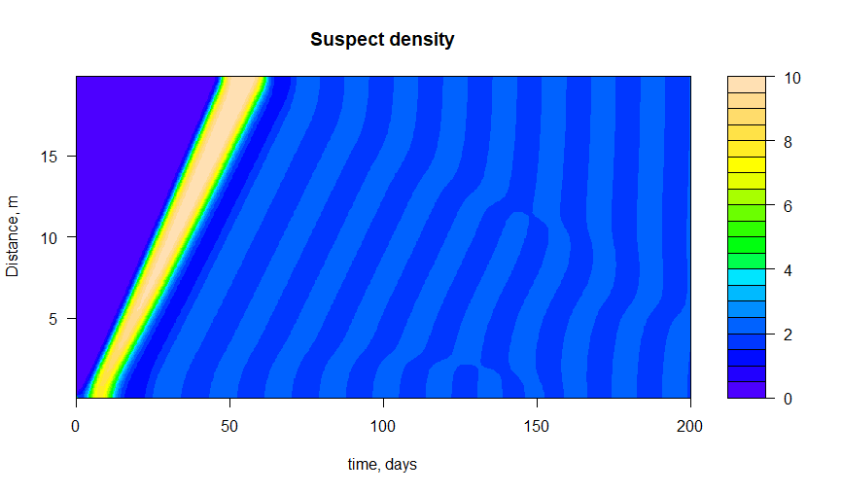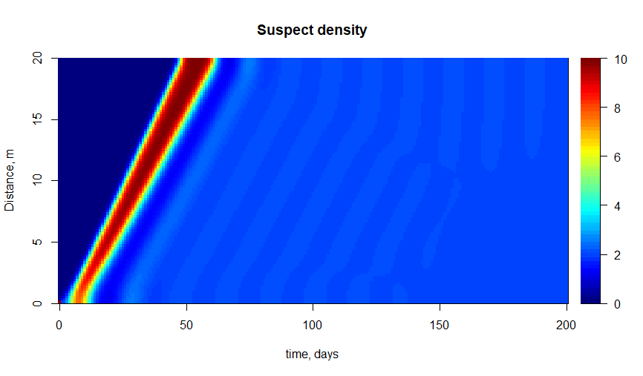

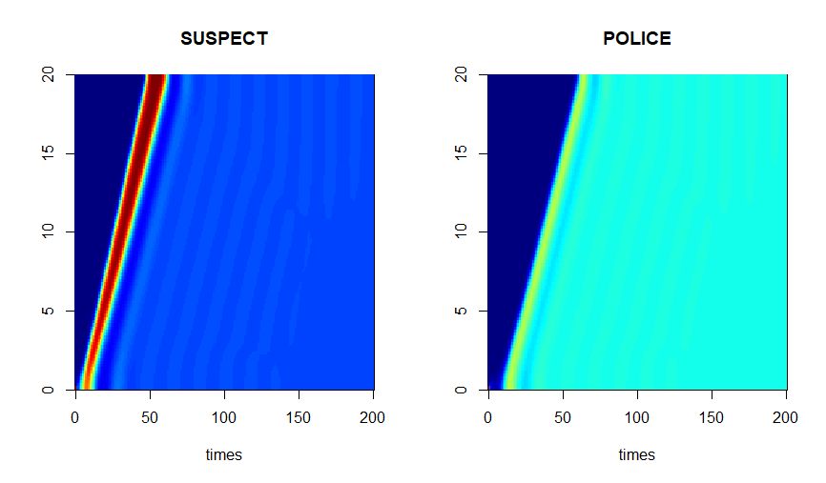

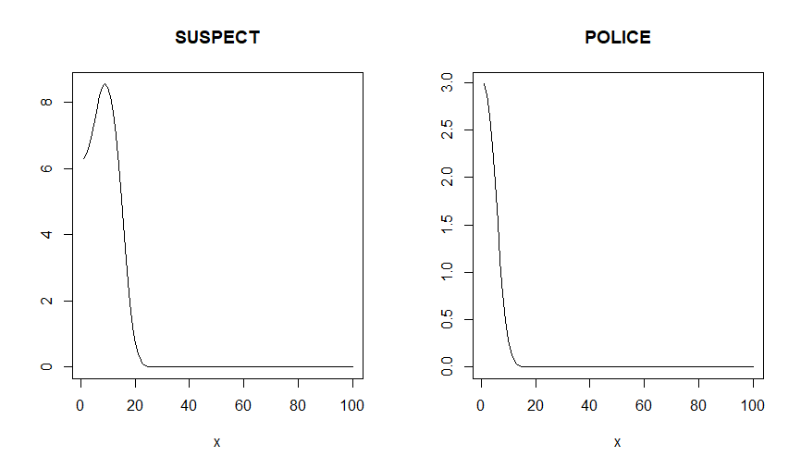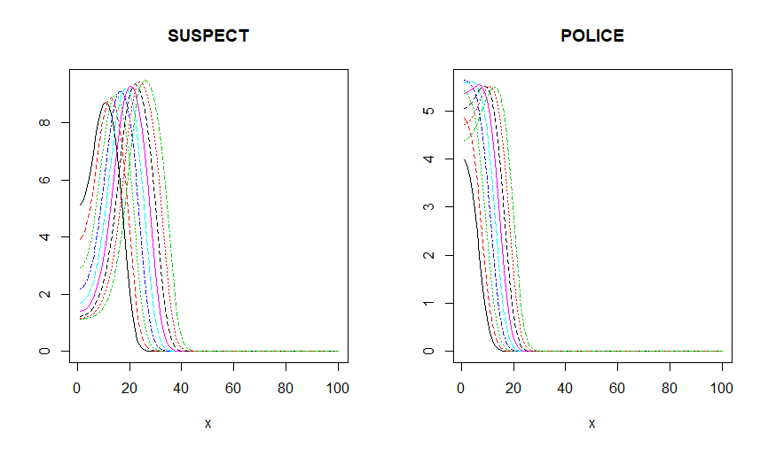

**Case2 images:**

